
This Photo by Unknown Author is licensed under CC BY-NC

GUIDANCE FOR
STUDENTS & PARENTS

AFTER THE EXAMINATIONS
Results and Post-Results

Centre Number: 37671

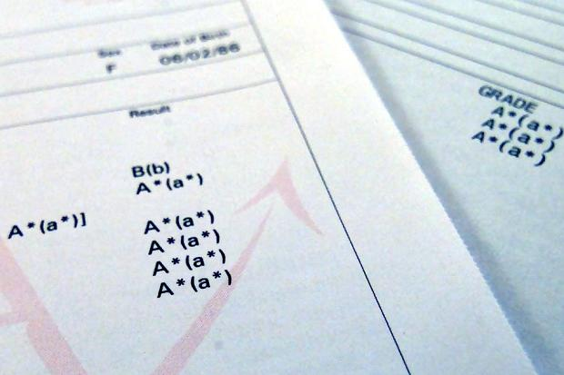

This guide aims to give valuable advice for examination results
received by candidates at St Mary’s.

Please read this document carefully
and retain it for future reference

If there are ANY questions or problems, please contact:
The Exams Officer – s.jennings@stmarysmenston.org

CONTENTS

CONTENTS 2
AFTER THE EXAMINATIONS 3
Notification of Results 3
STATEMENT OF RESULTS 3
POST RESULTS SERVICES 4
Reviews of Marking 4
Deadlines: 4
CERTIFICATES 5
APPENDICES 6
Appendix A 6
JCQ Appendix A 7
JCQ Appendix B 8

AFTER THE EXAMINATIONS

Notification of Results

GCE:
Results will be issued to students from 8:00am on Thursday 12 August 2027.

Staff will be available in school from 8:30am to deal with any specific exam / careers related guidance you may require. All students and parents are welcome to join in the celebrations in M1.

GCSE:
Results will be issued to students from 8:30am on Thursday 19 August 2027.

Staff will be available in school from 8:30am to deal with any specific exam / careers related guidance you may require. All students and parents are welcome to join in the celebrations in the gym.

Once students have collected their results in the gym they then progress to M1 to discuss their post-16 progression with a Sixth Form member of staff.

If students are unable to collect their results in person, they can authorise someone to collect them on their behalf or provide a stamped addressed envelope addressed to The Exams Officer and these will be posted out on the day.

STATEMENT OF RESULTS

On results day you will receive a ‘Statement of Results’. THIS IS NOT YOUR FINAL CERTIFICATE. The statement lists ALL the exams you have taken and any components within the qualification.

POST RESULTS SERVICES

Reviews of Marking
All Reviews of Marking (ROMs) should first be discussed with the relevant Faculty Leader and/or Subject Teacher who will advise on the viability of such a request. The “Review of Marking Form” should then be completed and signed (Appendix B). Accounts will be charged upon application via ParentPay. If you are entitled to a refund it will be processed in due course.

In the school’s experience, it is unusual for marks to change upwards by more than a marginal amount. However, the school reviews the marks that your child and others have achieved and will advise candidates if we feel there is an anomaly and that the paper should be reviewed. If we are concerned about results received for a particular subject, the school itself will request a review of marking of all those papers (with the candidate’s consent)
N.B Parents/Carers cannot request a Review Of Mark – this has to be authorised by the candidate who sat the exam.

Review of Marking categories are as follows:
SERVICE 1 CLERICAL CHECK
This service included the following checks:
That all parts of the script have been marked. The totalling of marks. The recording of marks. The application of any adjustments. The application of grade thresholds. The application of any special consideration, where applicable (indicate on form). The outcome of the re-check will be reported along with a statement of the total marks awarded for each unit/component included in the enquiry. The target for completion is within 20 calendar days of exam board receiving request.
SERVICE 2 (Mark review)
This is a post-results review of the original marking to ensure that the agreed mark scheme has been applied correctly. The service is available for externally assessed components of both unitised and linear specifications.
The deadline for completion is within 30 calendar days of the awarding body receiving the request. This service will include:
➢ the clerical re-checks detailed in Service 1;
➢ a review of marking as described above;
➢ if requested, a copy of the reviewed script(s) for those units/components included as part of the Access to Scripts service. (If the nature of the unit/component is such that access to scripts cannot be arranged, such as externally assessed GCE AS and GCE A2 Modern Foreign Language Speaking tests, then a report/copy of the record sheet may be requested. Awarding bodies will advise centres of the mechanism by which reports may be requested.)
PRIORITY SERVICE 2P (Mark review)
This service is as Service 2. However, it is only available if a GCE A-level candidate’s place in higher education is dependent on the outcome.
Any applications not meeting these criteria will be treated as normal Service 2 requests. The deadline for completion is within 18 calendar days of the awarding body receiving the request.
ATS (Access to Script)
A photocopy or the original of the student’s script.

Deadlines:
Exam Board | Service 1 | Service 2P | Service 2 | Priority ATS | ATS
Exam Board | DEADLINE | DEADLINE | DEADLINE | DEADLINE | DEADLINE
Exam Board | 24 Sep-27 | 12 noon on the 2 September (GCE) | 24-Sep-27 | 12 noon on the 2 September GCE) | 24-Sep-27
Exam Board | Clerical Check | Priority Mark Review | Mark Review | Priority Access to Scripts | Access to Scripts

CERTIFICATES

Certificates are received in school in November. Students will be invited into school to receive these. If they are unable to attend, they must make arrangements to collect them from the Curriculum Office. It is the responsibility of the student to collect their certificates.

JCQ regulations state that certificates should be kept for 12 months. If they remain uncollected they may be disposed of securely.

Certificates are important documents. Most educational institutions and potential employers will ask to see your original certificates. If you lose or fail to collect your Certificates, you will need to obtain duplicates from the relevant Awarding Body. The Awarding Bodies no longer replicate certificates unless you can prove they were destroyed by theft, fire or flood; they will only issue a Statement of Achievement. This currently costs in the region of £40.00 per ‘Statement of Achievement’.

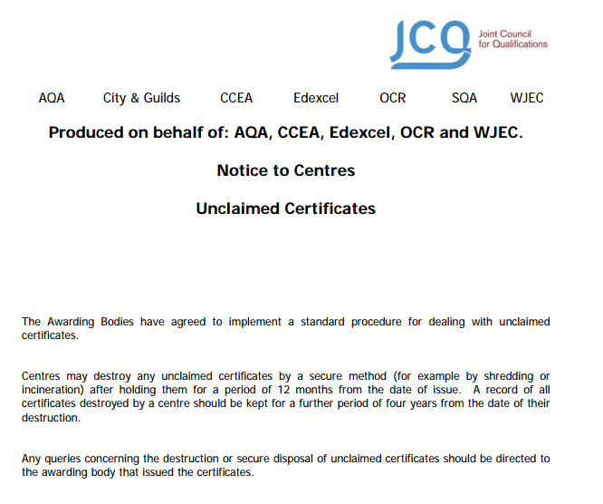

APPENDICES

Appendix A
Which post-results service suits you.
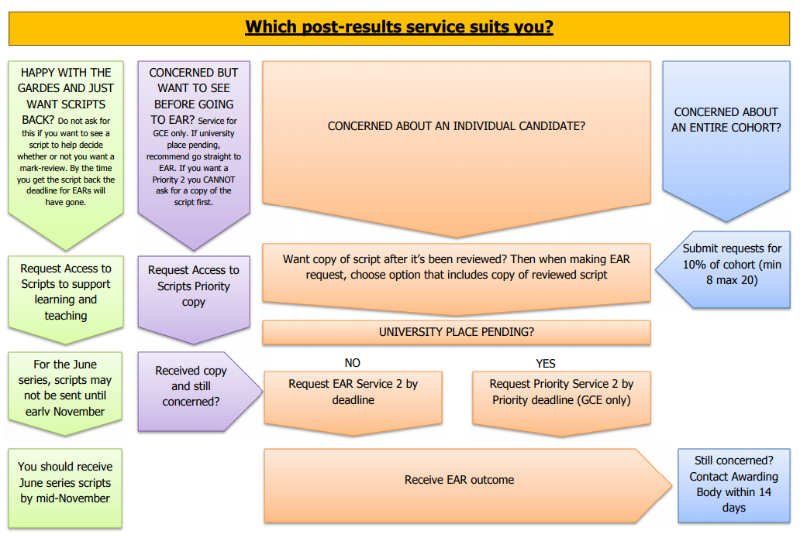

JCQ Appendix A
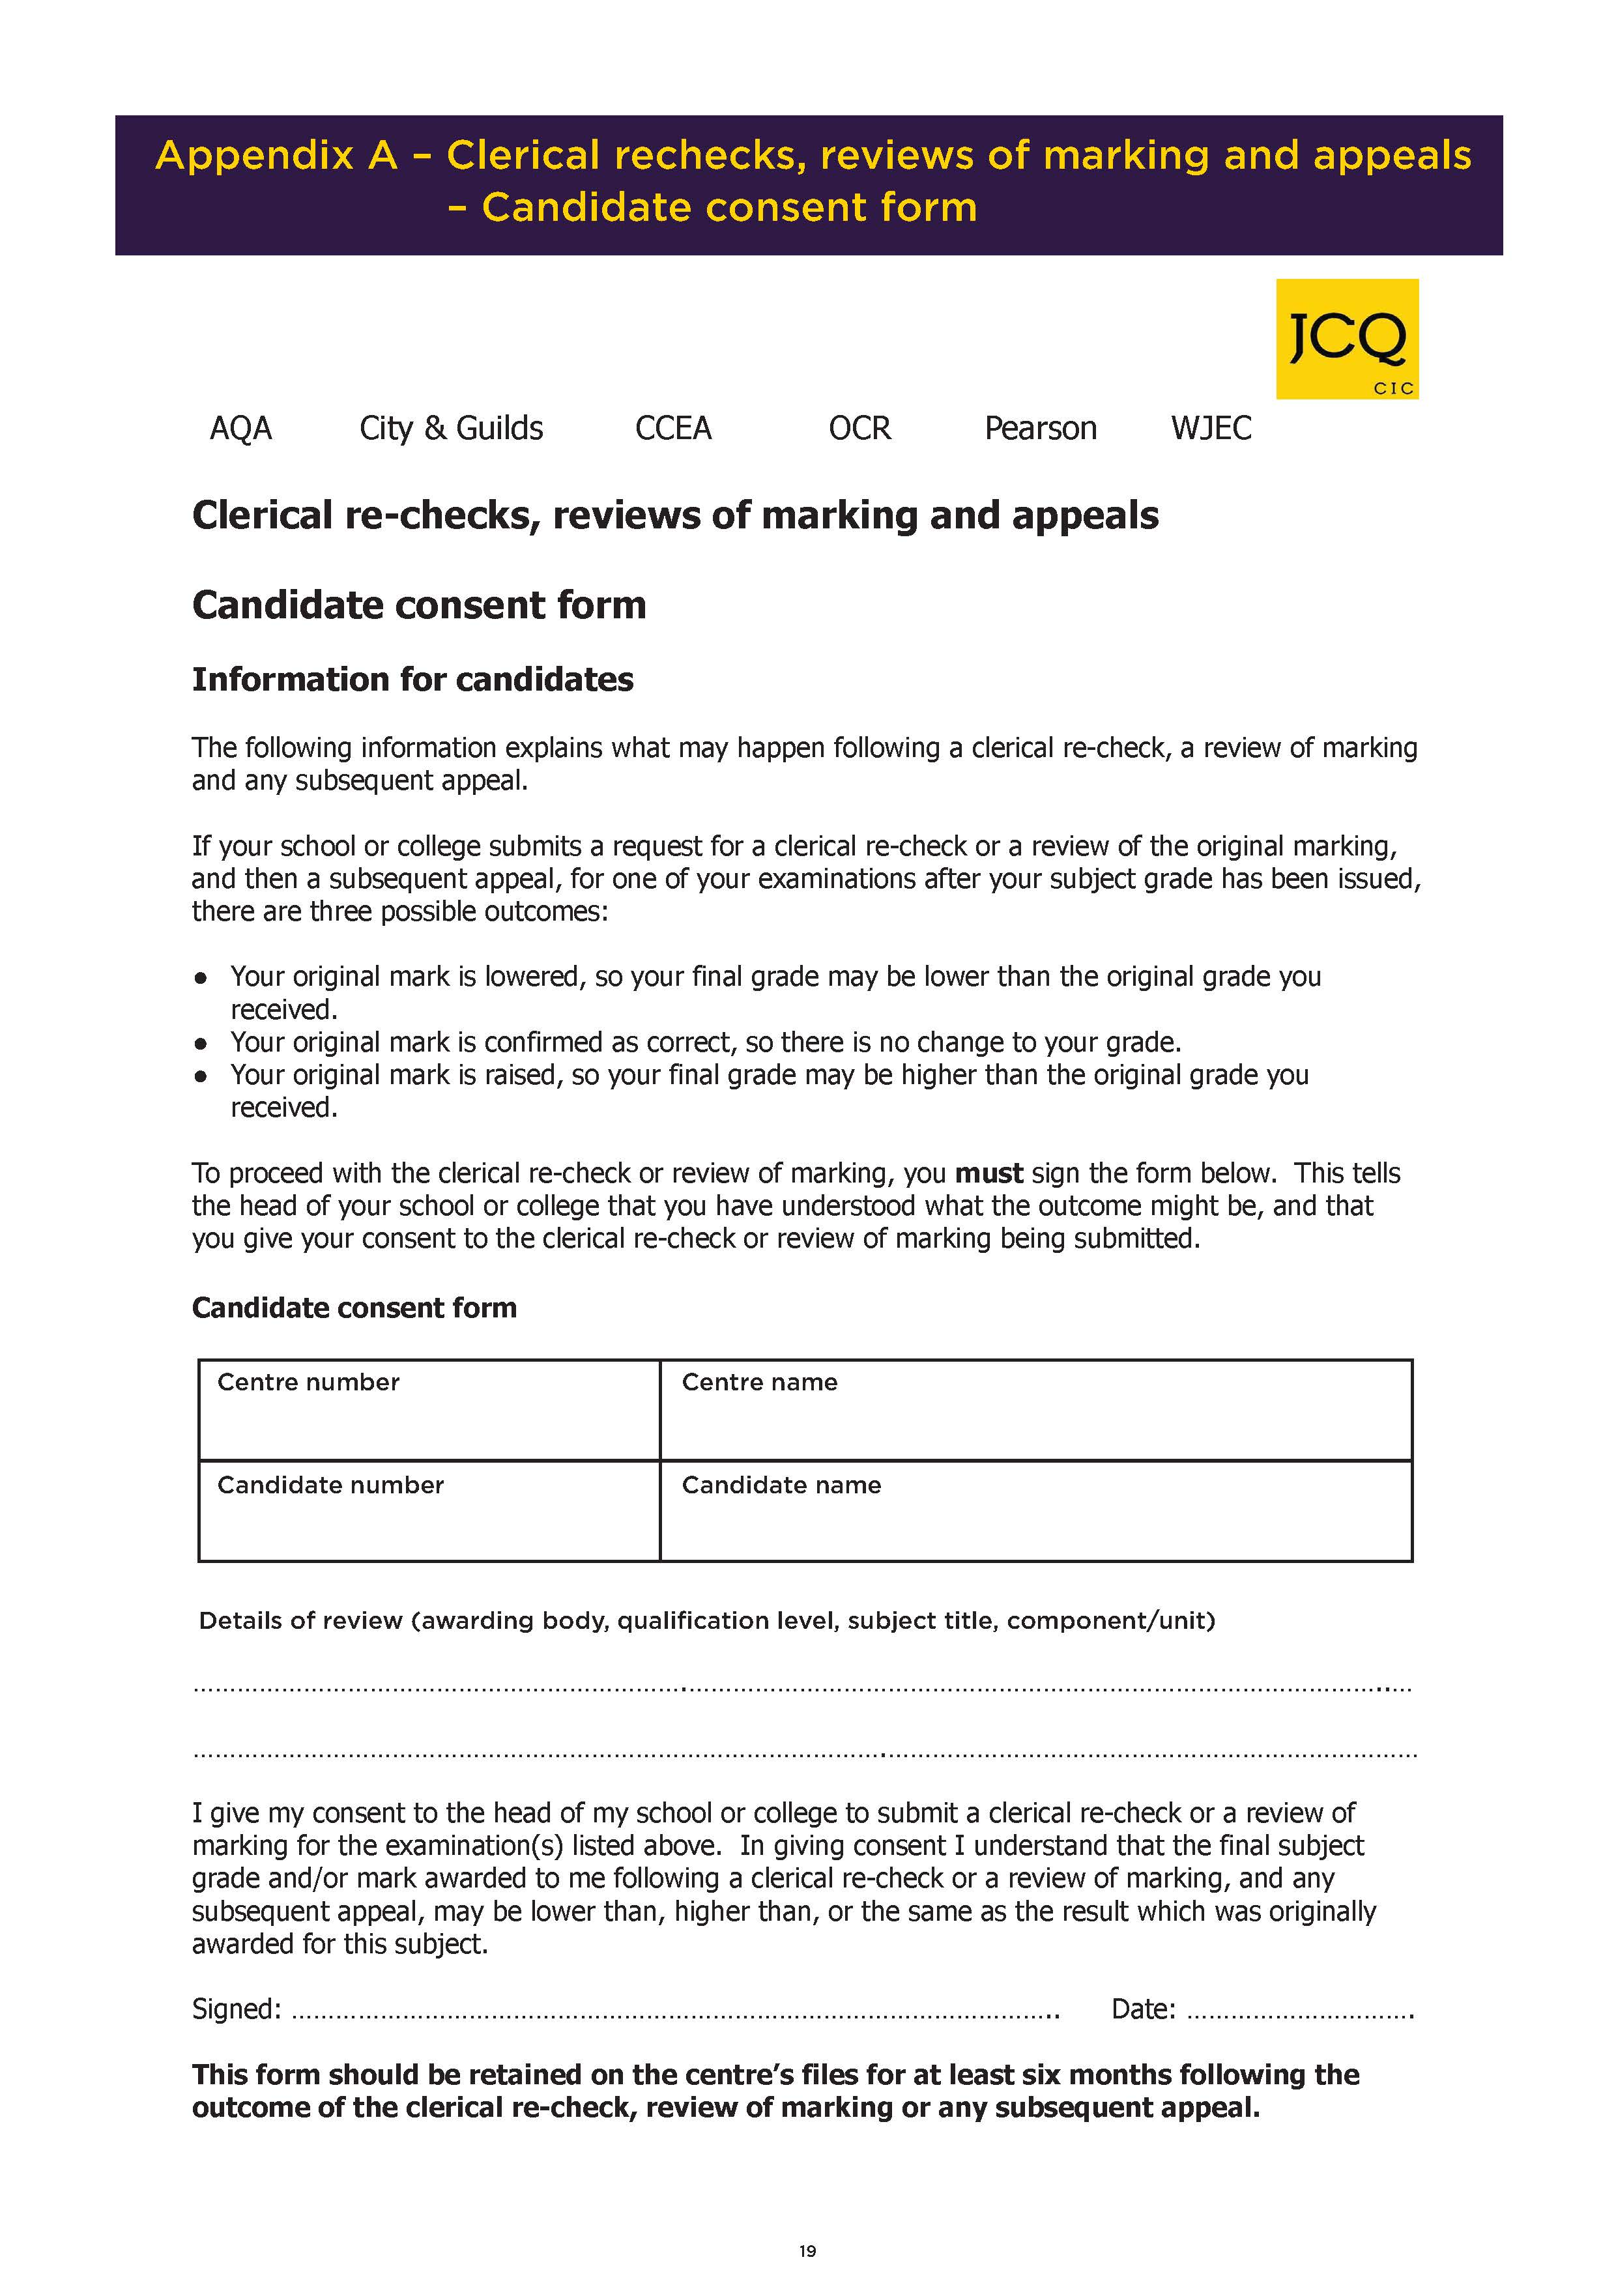

JCQ Appendix B
